### Project Title :

### **A CRM Application to Manage the Services offered by an Institution**

Name :Sparsh Kanugo

College:Dr.D.Y.Patil Institute of Engineering Management and Research,Akurdi,Pune

Salesforce Project Ready Program

# Project Overview

EduConsultPro Institute is a leading educational institution offering a variety of courses and programs in diverse fields. With a growing number of prospective students seeking admission each year, the institute faces challenges in managing the admission process, students enquiry, and expert consulting services efficiently. To address these challenges, EduConsultPro Institute decides to leverage Salesforce CRM to streamline the admission process and enhance the overall experience for both students and admissions staff.

The use case focuses on the admission process for prospective students interested in enrolling in courses and programs offered by EduConsultPro Institute. The goal is to provide a seamless and transparent experience for students while enabling admissions staff to efficiently review and process admission applications, students enquiry and case management.

The CRM (Customer Relationship Management) application is designed to streamline and enhance the management of services offered by EduConsult Pro Institute.This application will provide a centralized platform to track interactions with students, faculty, and external stakeholders, enabling the institution to deliver high-quality services efficiently.

# Objectives

The primary objective of the CRM application for managing services at Educonsult Pro is to centralize and streamline data management to enhance operational efficiency. By creating a unified platform, the application aims to improve communication between students, faculty, and administrators, fostering a collaborative environment.

Another key objective is to facilitate the tracking of service requests, ensuring timely responses and resolution while enhancing user experience. The application also seeks to provide valuable insights through analytics and reporting tools, empowering decision-makers to assess service performance and make informed improvements.

Ultimately, the goal is to create a user-friendly interface that caters to the diverse needs of all stakeholders, driving higher engagement and satisfaction with the services offered by the institution.

# Salesforce Key Features and Concepts Utilized

Salesforce is a powerful Customer Relationship Management (CRM) platform widely used by institutions to manage services, improve customer engagement, and streamline operations. In the context of a CRM application designed to manage services offered by an institution, several key Salesforce features and concepts come into play, including **Objects and Data Models**, **Automation Tools**, **Security Controls**, **Reporting and Analytics**, **Customization Capabilities**, and **Integration Options**.

**1.Objects and Data Models**: In Salesforce, data is structured around Objects (akin to tables in a database), and institutions can utilize both Standard Objects (like Accounts, Contacts, and Cases) and Custom Objects tailored to specific service offerings. These objects help manage and store data related to customers, services, and interactions, providing a structured framework for service management

**2.Automation Tools**: Salesforce offers several automation tools, including Workflow Rules, Process Builder, Approval Processes, and Flows, which can streamline repetitive tasks and enhance efficiency. For example, workflows can automatically assign tasks, send notifications, or update records based on specific triggers, improving response times and reducing manual effort.

**3.Security Controls**: Security is essential in managing sensitive data within a CRM. Salesforce provides robust security features, such as Role-Based Access Control, Profiles, and Permission Sets, to ensure data access is limited to authorized personnel only. Additionally, features like Field-Level Security and Sharing Rules offer granular control over who can view or edit specific data fields or records.

**4.Reporting and Analytics**: To help institutions gain insights into service performance and customer engagement, Salesforce provides advanced Reporting and Dashboard capabilities. Custom reports can track service metrics like case resolution times, customer satisfaction, and service usage. Dashboards provide visual representations of data, aiding in quick decision-making and continuous improvement

**5.Customization Capabilities**: Salesforce offers extensive customization options through Apex Code, Visualforce, and the more modern Lightning Components. These features enable developers to create tailored interfaces, workflows, and logic specific to the institution’s needs, enhancing user experience and functional alignment with institutional goals.

# 4. Detailed Steps to Solution Design

Implementing a CRM application using Salesforce to manage services offered by an institution involves several structured steps. Each step focuses on planning, building, testing, and deploying the solution. Here’s a detailed breakdown of the steps:

### 1. ****Requirement Gathering and Analysis****

* **Identify Stakeholders**: Determine the main users and departments involved (e.g., customer support, service teams, management).
* **Gather Requirements**: Conduct workshops, interviews, or surveys with stakeholders to gather information about required features (e.g., service management, customer tracking, reporting).
* **Define Scope**: Identify specific processes and services the application will handle, ensuring alignment with institutional objectives.
* **Document Requirements**: Create a requirement specification document, outlining key functionality and project goals.

### 2. ****Design and Planning****

* **Data Model Design**: Plan the objects (standard and custom) needed. For instance, define relationships between objects like Account (for customer information), Contact (for individuals), Case (for service requests), and any custom objects for specific services.
* **User Role Mapping and Security Model**: Define the roles, profiles, and permissions to control data access and ensure compliance with institutional security policies.
* **Define Automation Requirements**: Identify repetitive tasks that can be automated, like notifications, record updates, or task assignments.
* **Prepare Solution Architecture**: Map out the solution architecture, including integrations with external systems, if needed (such as payment systems or third-party databases).

### 3. ****Salesforce Environment Setup****

* **Provision Sandbox Environments**: Set up Salesforce sandbox environments for development, testing, and staging.
* **Configure Standard Objects**: Customize Salesforce standard objects like Account, Contact, and Case as per the institution’s needs.
* **Create Custom Objects and Fields**: Build custom objects for services that aren’t covered by standard Salesforce objects, such as Service Offerings, Subscriptions, or Service Histories.
* **Set Up User Roles and Profiles**: Create profiles and roles with appropriate permissions to match the security design.

### 4. ****Implementation****

* **Develop Business Logic**: Use Salesforce automation tools (Process Builder, Flows, and Apex code where necessary) to implement workflows, approval processes, and business rules for service management.
* **Configure Page Layouts and Record Types**: Set up page layouts, record types, and compact layouts to enhance data accessibility and display relevant information for different user roles.
* **Build Custom Interfaces**: Use Lightning Components or Visualforce to develop custom user interfaces for more complex service management requirements or improved user experience.
* **Set Up Integrations**: Configure integrations with external systems using Salesforce Connect, MuleSoft, or APIs to sync data between Salesforce and other institutional systems (e.g., ERP or billing systems).
* **Implement Validation Rules**: Create validation rules to ensure data quality and integrity, such as mandatory fields for critical data or specific formats for service codes.

### 5. ****Testing****

* **Unit Testing**: Test individual components (like custom objects, automation rules, and integration points) to verify functionality.
* **System Testing**: Conduct end-to-end testing to ensure that all components work together as expected.
* **User Acceptance Testing (UAT)**: Engage end-users to test the system against real scenarios, gathering feedback for any needed adjustments.
* **Security Testing**: Verify that role-based access and other security features are configured correctly, ensuring that sensitive data is protected.

# 5.Testing and Validation

Unit testing is crucial for Apex classes and triggers in Salesforce to ensure that business logic and automation functions correctly before deploying to production. In the context of a CRM application for managing institutional services, unit tests verify that classes and triggers execute expected logic, handle edge cases, and meet performance criteria. Salesforce requires a minimum of 75% code coverage for deployment, making unit tests mandatory for all custom code.

To start, each Apex class and trigger is accompanied by corresponding test classes that focus on testing both positive and negative scenarios. For instance, if a trigger is designed to automatically create a "Service History" record whenever a "Service Request" is updated, test cases should cover scenarios where the Service Request status changes, ensuring that a new Service History record is created only under specific conditions. Negative tests check that the trigger does not create duplicate or incorrect records if the conditions aren’t met. Additionally, test classes validate error handling, such as how the system behaves when records are missing required fields or when record limits are exceeded.

Mock data is created using test setup methods to isolate tests from actual data, ensuring they are repeatable and don’t interfere with live records. Tests also account for various user permissions to verify that logic is restricted by user roles or profiles as intended. Performance testing is often incorporated to confirm that code executes efficiently without surpassing governor limits, especially for bulk operations. Comprehensive test coverage helps ensure a smooth deployment, reducing errors and maintaining the stability of the application.

User Interface Testing :

User Interface (UI) testing for a Salesforce CRM application that manages institutional services focuses on verifying the functionality, layout, and usability of the application's front-end components. UI testing ensures that users can navigate the application smoothly, interact with various elements intuitively, and complete tasks without encountering errors or inconsistencies. It covers areas like page layouts, forms, buttons, fields, and custom Lightning Components.

### Key Areas of UI Testing:

**Functional Testing**: This step validates that each UI component functions as expected. Forexample, if a user needs to create a new Service Request, testing ensures that the form fields are visible, accept the correct input format, and enforce mandatory fields. If there are buttons to save or submit the request, testers confirm that these trigger the correct actions, such as saving data and updating related records.

**Navigation and Workflow Testing**: Testing verifies that users can navigate through the application seamlessly. It covers navigation between different tabs (e.g., Accounts, Service Requests, Service History) and checks that links direct users to the correct pages. It also ensures that workflows (like creating a case and linking it to a service) are intuitive and logically structured for a smooth user experience.

**Layout and Responsiveness Testing**: UI testing assesses page layouts across devices and screen sizes to confirm responsiveness, especially for mobile users. For instance, the layout should adapt appropriately, and custom components should render correctly on tablets, desktops, and smartphones. This also includes testing for alignment, spacing, and readability.

**Data Validation**: Form field validation tests are essential to confirm that fields accept valid data and provide error messages for incorrect inputs. If a Date field requires a future date, the UI test ensures users receive an error message when entering past dates, helping to maintain data quality and user guidance.

**Permission-Based Access Testing**: Different user roles often have unique interfaces based on their permissions. UI testing ensures that each user sees only the components they’re authorized to access. For instance, a service manager might see fields for billing details, while a customer support agent has access only to customer information fields relevant to support.

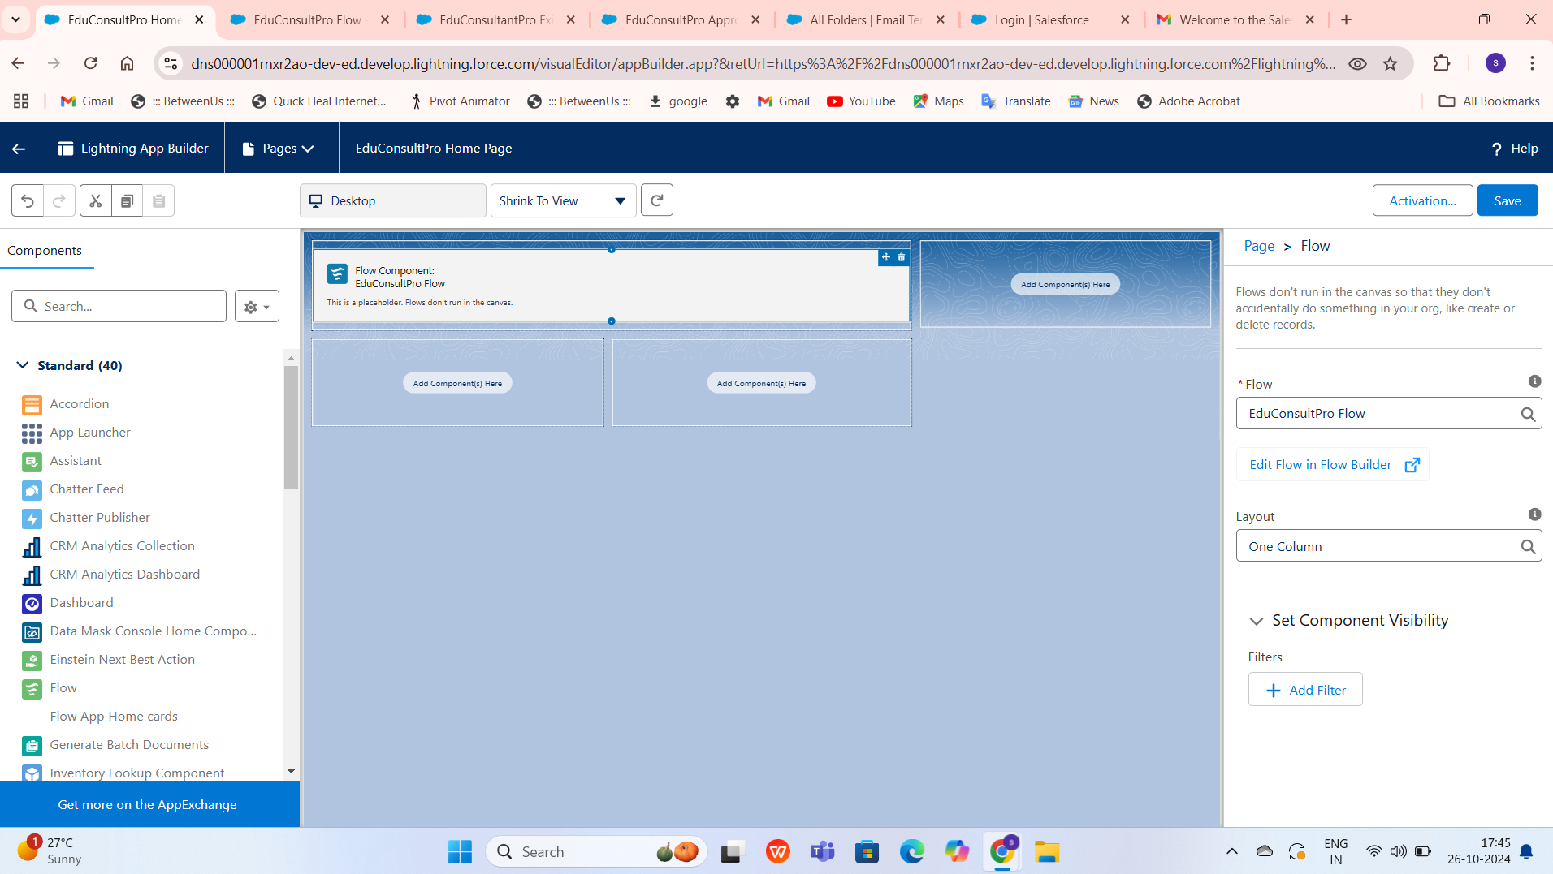

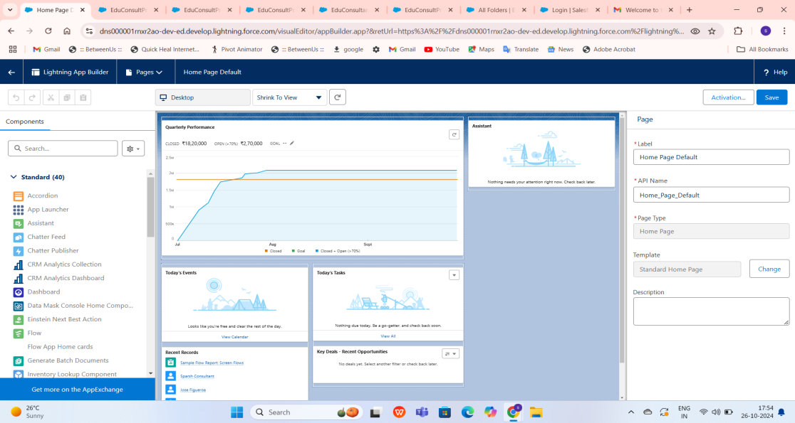

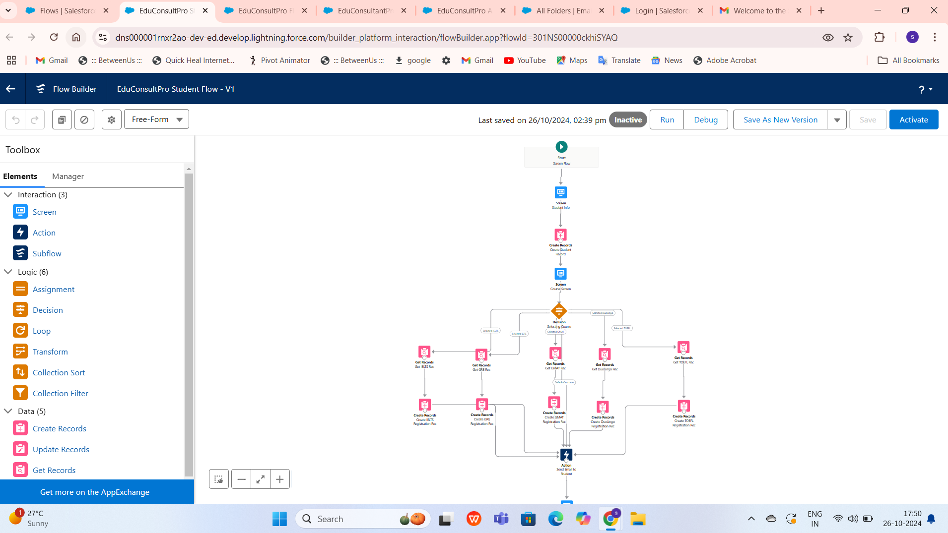

# Key Scenarios Addressed by Salesforce in the Implementation Project

In the implementation of a Salesforce CRM application to manage services offered by an institution, several key scenarios are addressed to ensure the system meets organizational needs, optimizes workflows, and enhances customer engagement. These scenarios guide the customization and configuration of Salesforce features, automation, and data management to streamline processes and improve service delivery.

### Key Scenarios Addressed:

**Customer Information Management**: A core scenario involves efficiently managing customer data. Salesforce’s Accounts and Contacts objects allow the institution to centralize customer profiles, making it easy to store and retrieve contact information, past interactions, service history, and more. This scenario enhances visibility into customer details, improves personalization, and enables better relationship management.

**Service Request Handling and Tracking**: Managing service requests is a vital use case for institutions. Through Salesforce’s Cases object and custom workflows, service requests can be captured, categorized, and tracked from start to finish. Automation tools like Flows and Process Builder can route cases to the right teams, send notifications to staff and customers, and update case statuses based on activity. This scenario reduces response times and improves accountability.

**Automated Communication and Notifications**: To ensure timely communication, Salesforce enables automated notifications for key events. For example, customers might receive automated emails when a service request is logged or resolved, while internal teams are notified of high-priority cases. By using Email Templates, Workflow Rules, and Triggers, this scenario ensures proactive communication and keeps both customers and staff informed.

**Customer Feedback and Satisfaction Tracking**: Post-service feedback collection isessential for quality improvement. Salesforce can automatically trigger feedback surveys through integrations with survey tools or custom email templates. This scenario providesinsights into service quality, allowing the institution to track satisfaction levels and make data-driven improvements.

**Service Performance and Metrics Tracking**: Salesforce’s Reports and Dashboards allow the institution to monitor key performance indicators, such as average response time, resolution rates, and customer satisfaction scores. These insights enable managers to gauge team performance, identify trends, and optimize service operations, aligning with continuous improvement objectives.

# Conclusion:

In conclusion, implementing a Salesforce CRM application for managing services offered by an institution provides a transformative approach to handling customer relationships, streamlining operations, and enhancing service quality. Salesforce’s robust feature set—ranging from customizable data models and automation tools to advanced reporting capabilities and secure access control—enables institutions to tailor the platform to meet specific service needs. By addressing key scenarios such as service request handling, customer information management, and automated communications, Salesforce allows the institution to optimize workflows and ensure a seamless experience for both staff and customers.

Moreover, the platform’s emphasis on user-friendly interfaces, collaboration tools, and comprehensive integration options supports cross-functional teamwork and a unified view of customer interactions, which are essential in delivering timely, consistent, and high-quality services. With Salesforce’s scalability, the institution is well-positioned to adapt as requirements evolve, enabling continuous improvements and the addition of new features over time.

The CRM’s data-driven insights empower decision-makers to identify trends, measure performance, and implement strategic changes based on real-time metrics, thereby contributing to both short-term operational efficiency and long-term institutional growth. Ultimately, Salesforce provides a reliable and dynamic foundation that fosters improved customer satisfaction, operational excellence, and competitive advantage, helping the institution fulfill its mission with greater impact and efficiency.